
Families can access your Binti by using the following links:
- Initial Foster Care Application: https://family.binti.com/users/signup/new-horizons-tx-initial

- Respite/Babysitting Application: https://family.binti.com/users/signup/new-horizons-tx-respite

These links can be posted on your website or other agency publications.

QR codes that can be scanned with a mobile device are provided for your convenience. The black QR code is for your initial foster care application and the blue QR code is for your respite and babysitting application. QR codes are helpful tools for printed recruitment materials that are posted around the community.
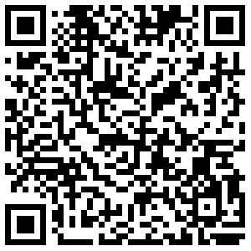
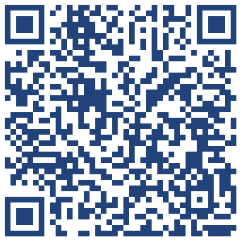

Anyone using these public links to sign into Binti for the first time will be automatically assigned to your "default recruiter" and an email notice will be sent to: fosteradopt@newhorizonsinc.com.

🔑 Your Binti Initial Foster Care Application template has a passcode. Think of this passcode as a “checkpoint” to ensure that a family moves through the licensing process in the way that best meets your agency’s needs:

- Passcode: newhorizons4kids
This passcode should be provided by New Horizons, to the family, after the family has reached the Orientation stage and spoken with New Horizons staff. This passcode will give the family access to move on to the Application & Background Checks stage and begin completing New Horizons’ requirements.

💙 Binti’s Support Team is here for you. The Binti Help Center is available 24/7 with articles and resources on how to use Binti. Monday-Friday, 8AM-9PM Central time, Binti also offers US-based live support via chat (the blue button in the bottom right corner of your Binti screen!), email (help@binti.com), and phone (1-844-424-6844).

🎬View your recorded Binti User Training video here!

🤝 Your dedicated Customer Success Manager will be Alex Arpag, and he can be reached at alex@binti.com. Carly will remain your main point of contact until late July and will be in touch to schedule an ongoing success transition meeting.

